**USER DOCUMENTATION**

Contents

About Swordfish API 2

Use of Swordfish API 2

REST Operations: 2

API functionality demonstrated using Postman: 2

# About Swordfish API

The Swordfish emulator allows user to create, read, delete and update Rest operations.

This Swordfish is an extension of Redfish emulator (“**DMTF REDFISH EMULATOR**”). The Redfish emulator is available from the DMTF public github repository: <https://github.com/DMTF/Redfish-Interface-Emulator>

Users have to follow some installation steps which are in the installation documentation for Swordfish Emulator README file (note that this includes pointers to the Redfish Interface Emulator installation).

# Use of Swordfish API

## REST Operations:

Swordfish supports restful commands (GET, POST, PUT and DELETE). To perform these operations we can use any REST interface. In this document we demonstrate all interactions using Postman, which is available as a standalone app or as a browser plugin.

## API functionality demonstrated using Postman:

Basically Postman is supported in chrome browser. User has to create an account in Postman and use it for testing the REST API functions.

Postman is used for all rest operations. Each example shown below describes a REST operation followed by a figure showing the basic operation, as well as an example result and payload.

1. Basic GET operation for Service root

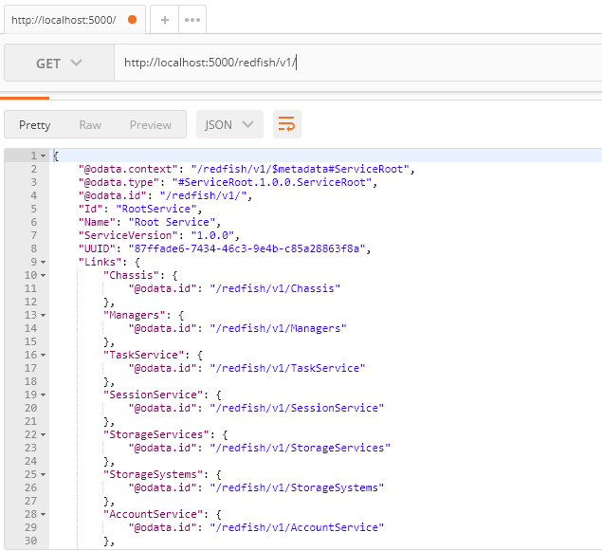

Below screen is used to GET “Storage Services Collection data. Here we can see Members and members @odata.count.

**Command**: **GET** http://localhost:5000/redfish/v1/StorageServices

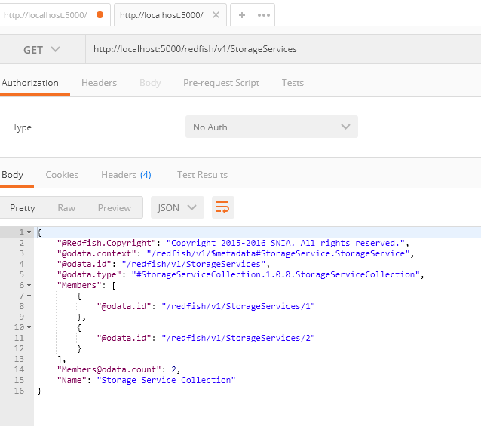

A User can add new member of a collection data by using” post” command. It will create a new instance of a resource and subresources.

1. Adding New element /member to collection using “POST”

**Command**: **POST** <http://localhost:5000/redfish/v1/StorageServices/3>

The below result shows after adding “3” to members of Storageservices.

Check It by **GET** http://localhost:5000/redfish/v1/StorageServices/3

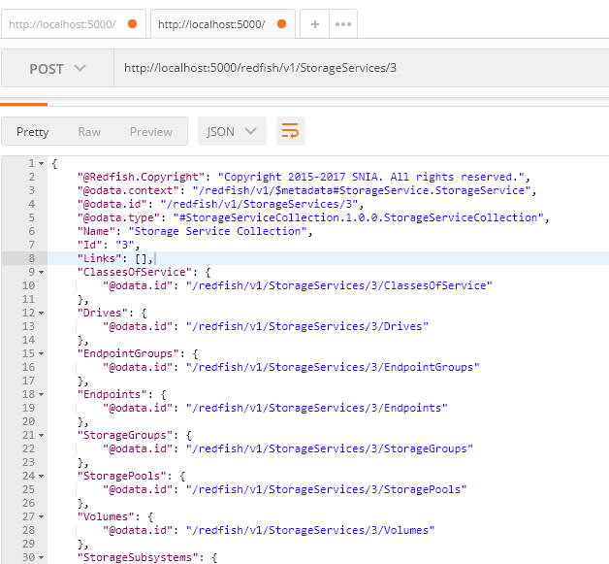

1. Adding a member of Volume using “Post”

user creating new child collection i.e. StorageServices/3/Volumes/1

**Command**: **POST** http://localhost:5000/redfish/v1/StorageServices/3/Volumes/1

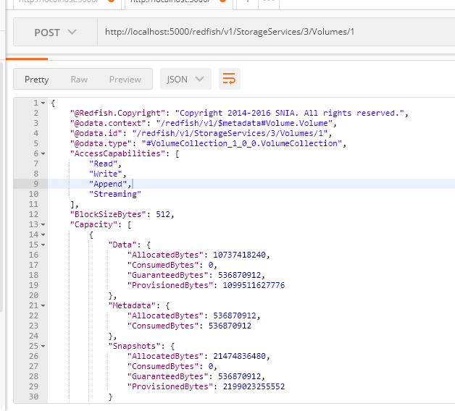

1. Edit all the properties of an element in a collection using “PUT”

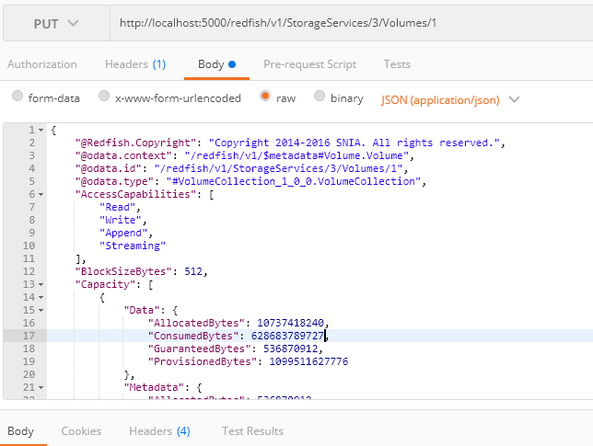

* User have to pass complete json file to the body and modify the content in volumes/1
* User need to declare Json(application/json) before sending the request.

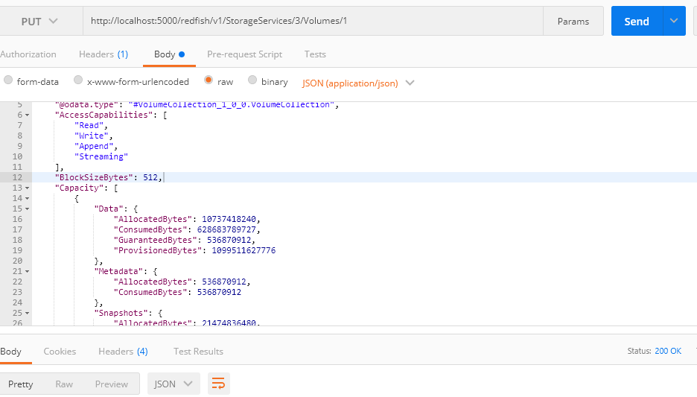

1. Deleting an element of member Collection in “Volumes”.

User can’t delete more than one element in a single request .

